**APPLICATION OF AI IN INDUSTRY**

**Ayushi Pandey (5058), Vishakha Yadav (5061), Bharti Mishra (5012), Prachi (5005)**

Ayushi Pandey (18/5058) - [ayushepandey@gmail.com](mailto:ayushepandey@gmail.com)

Vishakha Yadav (18/5061) - [vishakhayadav036@gmail.com](mailto:vishakhayadav036@gmail.com)

Bharti Mishra (18/5012) - [bhartimishra6385@gmail.com](mailto:bhartimishra6385@gmail.com)

Prachi (18/5005) - goyal.prachi2301@gmail.com

**Abstract:-**

This paper reviews application of AI in industries .Our research finds that AI’ s main application in the industry is in the health care, military armed forced, robotics, marketing, E-commerce, Food technology, Travel, Entertainment and Gaming. This paper also describes why we need AI in industry, its key element, applications, its Facilitators etc.

**Keywords: -**

Marketing, catboats, army, military, robotics, customers, Analytics, Catalog Management, Voxel Morph.

**INTRODUCTION:-**

The concept of artificial intelligence was initially proposed in the 1940.Industrial artificial intelligence, or industrial AI, usually refers to the application of artificial intelligence to industry.

Unlike general artificial intelligence which is a frontier research discipline to build computerized systems that perform tasks requiring human intelligence, industrial AI is more concerned with the application of such technologies to address industrial pain-points for customer value creation, productivity improvement, cost reduction, site optimization, predictive analysis and insight discovery.

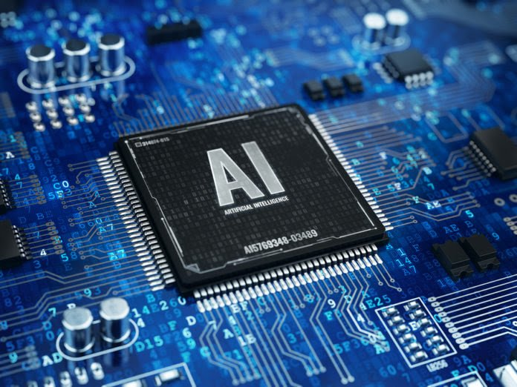Big data and AI give Industry 4.0 a huge boost. Intelligent software solutions can use the high volumes of data generated by a factory to identify trends and patterns that can then be used to make manufacturing processes more efficient and reduce their energy consumption.

**Why we need Ai in industries**

Artificial intelligence is based on the principle that human intelligence can be defined in a way that a machine can easily mimic it and execute tasks, from the most simple to those that are even more complex. To understand How Artificial Intelligence actually works, one needs to deep dive into the various sub domains of Artificial Intelligence and understand how those domains could be applied into the various fields of the industry.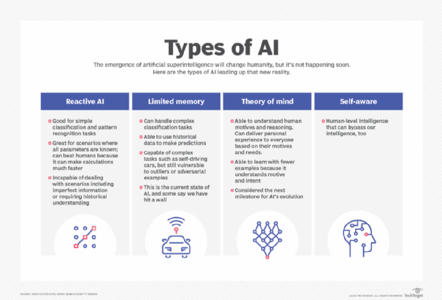

As the data keeps on increasing in today's world we need AI in almost every industry. The data used in industries is quite large so we need neural networks and deep learning to solve the complex data. As machine learning alone cannot handle large amount of data so we need neural networks, deep learning, natural language, processing, computer vision and cognitive computing altogether .AI programming focuses on three cognitive skills: learning, reasoning and self-correction.

The four major categories of industrial AI are:

DT (Data Technology)

AT (Analytic Technology)

PT (Platform Technology)

OT (Operation Technology)

The strength of its army is one of the factors indicating how powerful the country is. In some of the most developed nations, investment in this sector is the highest as compared to other sectors. A major part of this investment goes towards rigorous research and development in modern technology such as AI in military applications. AI-equipped military systems are capable of handling volumes of data efficiently. In addition to that, such systems have improved self-control, self-regulation, and self-actuation due to its superior computing and decision-making capabilities.

**Applications of AI in Military**

This section presents a few examples where AI can be applied to enhance military capability.

**Surveillance**

Maritime surveillance is performed using fixed radar stations, patrol aircrafts, ships, and in recent years electronic tracking for maritime vessels using the automatic identification system (AIS). These information sources provide voluminous amounts of information about vessel movement that may reveal illegal, unsafe, threatening, and anomalous behavior. However, the large amounts of information about vessel movement makes it difficult to manually detect such behavior. Instead ML-approaches are used to generate normality models from vessel movement data. Any vessel movement that deviates from the normality models is considered anomalous and presented to operators for manual inspection. An early approach to maritime anomaly detection use the Fuzzy ARTMAP neural network architecture to model normal vessel speed based on port location. Another approach use associative learning of motion patterns to predict vessel movement based on its current location and direction of travel. Others use unsupervised clustering based on Gaussian mixture models (GMM) and kernel density estimation (KDE) .The models enable detection of vessels that change direction, cross sea lanes, move in the opposite direction or travel at high speed. More recent approaches use Bayesian networks to detect false ship type, as well as discontinuous, impossible, and loitering vessel movement. Future developments of maritime anomaly detection should also consider surrounding vessels and interaction among multiple vessels.

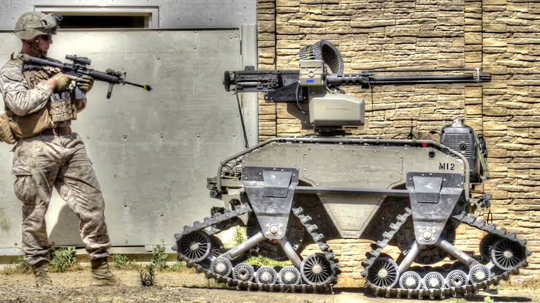 **Underwater mine warfare**

Underwater mines pose a significant threat to marine vessels and are used to channel movement or deny passage through restricted waters. Mine countermeasures (MCM) therefore tries to locate and neutralize mines to enable freedom of movement. Mine searches are increasingly performed with an autonomous underwater vehicle (AUV) that is equipped with synthetic aperture sonar (SAS), which provides centimeter-resolution acoustic imagery of the seafloor. Since AUVs collect large amounts of SAS imagery, automatic target classification is useful to discriminate potential mines from other objects. While automatic target classification of mines has been studied for a long time, the high performance of DNNs for image classification has created an interest in how such approaches may be useful for automatic mine detection. A few studies show the potential of DNN for mine detection. For example, describes how dummy mine shapes, mine-like targets, man-made objects and rocks where placed on the seafloor on various geographic locations. An AUV was then used to survey the seafloor with an SAS. Further studies may investigate how to discriminate mines from all types of clutter objects, combine detection and classification, as well as robustness to noise, blur, and occlusion.

**CHALLENGES:**

**Transparency:-**

Many applications require, in addition to high performance, high transparency, high safety, and user trust or understanding. Such requirements are typical in safety critical systems, surveillance systems, autonomous agents, medicine and other similar applications. With the recent breakthrough for AI, there is also an increased research interest in transparency to support end-users in such applications.

**Data:-**

Developing ML-based applications in a military context is challenging because the data collection procedures in military organizations, training facilities, platforms, sensor networks, weapons, etc. were initially not designed for ML-purposes. As a result, in this domain it is often difficult to find real-world, high-quality and sufficiently large datasets that can be used to learn from and gain insight into.

**Vulnerabilities:-**

The two different aspects of vulnerabilities of DNNs:-

1) Vulnerability for manipulation of input and

2) Vulnerability for manipulation of the model.

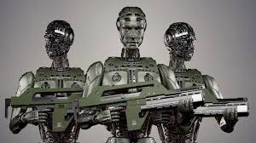**MILITARY OPERATIONS:**

AI will support armed forced in collecting, categorizing and analyzing data more quickly and efficiently.AI enabled systems can assist with collecting images or signals collecting by drones and categorizing and transmitting them accordingly to the requirements of multiple recipients. A drone's data could be transmitted in a real time to a frontline artillery unit as well as to an HQ intelligence cell without requiring time consuming "translations" at various interfaces.

**Application of AI in Travel and Tourism**

AI in travel and tourism is used to make the whole travel experience more convenient and enriching. The travel industry is leveraging the benefits of AI technology to predict travel choices, provide personalized travel solutions tailored to customer needs, and improve customer service, and make in-trip and post-trip needs management simpler.

**Example... (Chabot’s)**

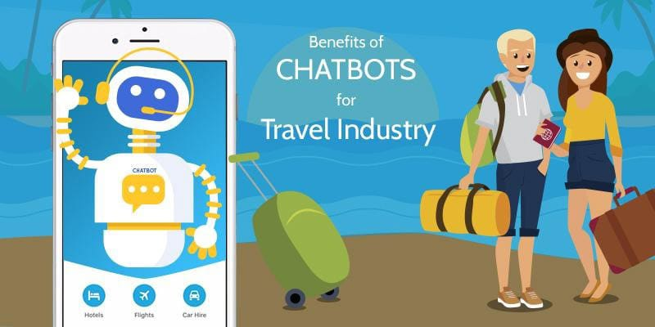Travel industry is a field where the businesses have to be attentive 24/7. Practically, you cannot deploy staffs to work because it is going to cost you much more. In a situation like this, Chabot favors you. The use of AI in Chabot helps in solving the queries of a prospective client in real-time.

They are found very effective in solving online queries and hence help businesses increase the number of conversions.

**Real applications of AI in travel industry...**

* 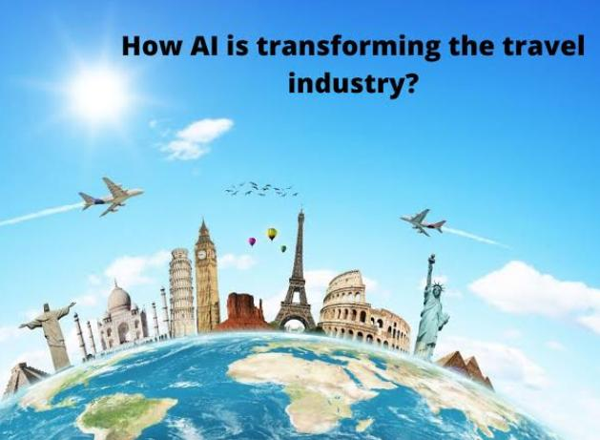**Estimates of flight and hotel rates: -** today the smart tools that monitor and send timely alerts with interesting offers are in great demand in the travel industry.
* **Smart travel assistants:-**In most cases, virtual travel assistants are integrated with popular instant messaging applications, such as Facebook Messenger, Slack, Telegram or Skype, and are trained to perform various tasks: from searching for the cheapest offers, booking flights and making hotel bookings, to planning complete trips and improving your general customer experience
* 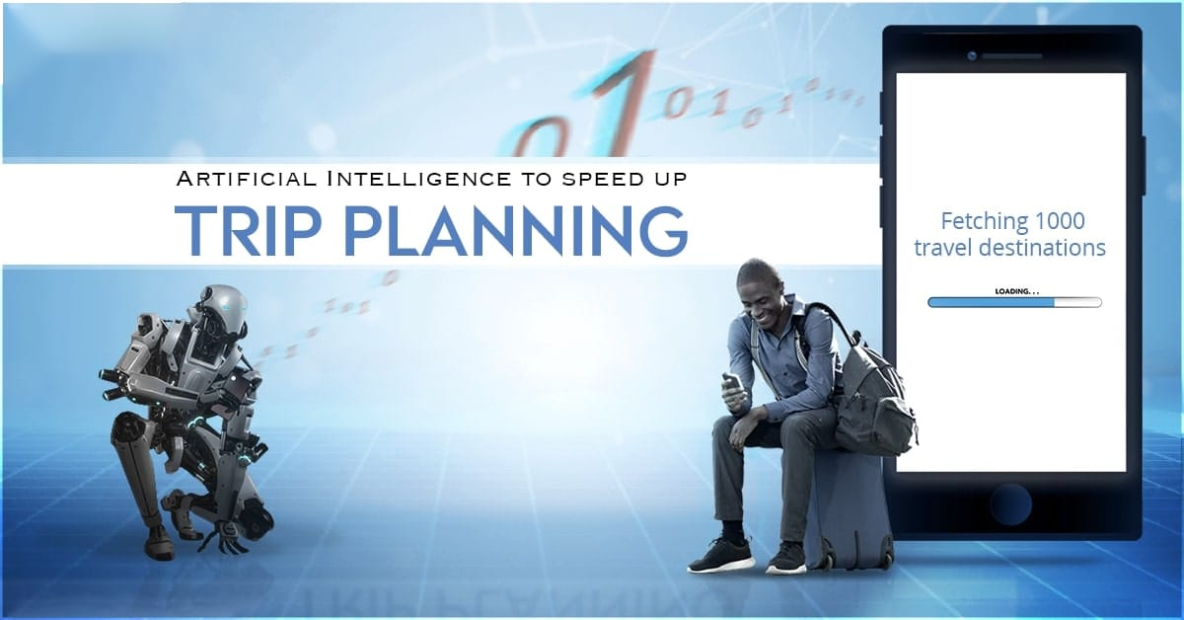**Sentiment analysis in social networks:-**90% of American travelers with smartphones share their experience, photos and opinions about services on social networks, according to Amadeus. This large pool of valuable data can be analyzed by the industry to improve its services.

**Pros:-**

1) Save time

2) Save cost

3 increase efficiency

**Cons:-**

1) Leads to unemployment

2) Few experienced programmers

3) High cost (machines)

**Application of AI in food industry**

The widespread adoption of AI and automation will impact how restaurants employ and utilize staff. The benefits of AI in the restaurant industry extend beyond robots taking orders, making and delivering food. AI is also able to help restaurant owners make sense of data to improve the diners' experience.

**Challenges** to the adoption of artificial intelligence technology in the food industry:--

Setbacks to the adoption of AI technology include

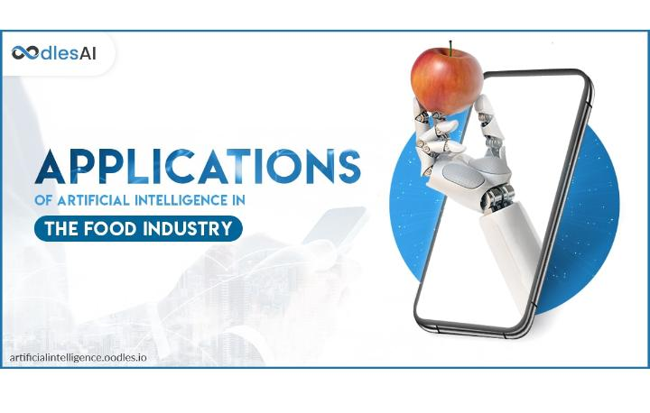The cost of AI deployment which means that only giant players in the food industry afford it.

**Cultural challenges:** - as with all technical advancements, the deployment of AI is associated with fear. The fear that computers are taking over and the fear that such technologies can be negatively manipulated in future, the fear that Power will be left in the hands of few and that humans will lose their jobs to computers. These could lead to companies getting detested from embracing A

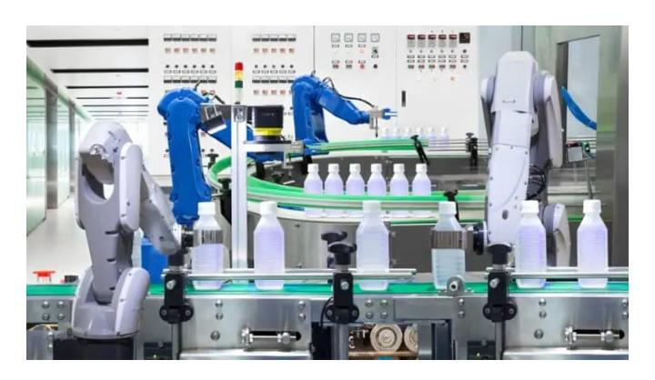

**Application of AI in food processing...**

* **Sorting food products & packages:-**TOMRA, one of the best companies in food sorting, revealed that 90% of the food is sorted out with the help of human resources/labor before the 21st century. Currently, the situation is different; most of the food sorting plants are shifted to automated processes.
* **Ensuring personal hygiene: -** As we care about our kitchen with the utmost cleanliness, AI also making sure to maximize food processing plant hygiene that helps in making sure that the plant is running with rules and regulations.
* **Developing new products: -** Now, most of the food processing and packaging industries are taking the help of the AI to develop & introduce into the market.

**Pros:-**

1) Enhancement of speed.

2) Yield improvement

3) Minimization of labor costs.

**Cons:-**

1Risk of unemployment

2) It can't replace humans.

3) Lacks Creativity

**Application of AI in Health and Care**

The largest impact of AIis in health care. In going to the latest report of PWC the AI will contribute an additional 15.7 trillion to the world economy by 2030 and the greatest impact will be in the field of Health-care so we know healthcare is getting more importance or is used in health care field in advanced manner.

**Reason behind sudden growth of Health Industry in AI:**

**(1.) High Availability of medical data**

AI is based on technologies such as Deep Learning and Machine Learning which needs tons and tons of data so due to availability of data it become easier to implement AI in healthcare Industry.

**(2.) Development of Complex Algorithms**

Machine Learning is not capable of handling high dimensional data and particularly the medical data which has high dimensionality so for us to process and analyze such large dimension data Deep Learning and Neural Networks are used that basically focus on solving complex Problems. Deep Learning and Neural Networks plays a major role in the field of Health-care in AI.

**Use cases of AI in health-care:**

**(1.)** **AI implementing Cognitive Technology**

AI is basically benefiting health-care organizations by implementing cognitive technology in order to unwind a huge amount of medical records and in order to perform any power diagnosis.

For Example: Nuance basically helps in storing, collecting and reformatting data in order to provide faster and more consistent access to all the data so that any further analysis or any other diagnosis can be performed.

**Key features of Nuance:**

**(1.)** Service Acceleration

**(2.)** Call Deflection

**(2.) AI in Medical Diagnosis**

One Major Application of AI in Medical Diagnosis is the MRI Scans.AI has taken over the complex analysis of MRI Scans and it has made MRI scan a much simpler Process. MRI Scan contain a large amount of data. Normal MRI Analyzers will take hours to find desired results but Deep Learning is a solution to this large problem as large and complex data can be analyzed with the help of Neural

Networks and this is exactly what a team of MIT implemented. In MIT, they develop a Neural Networks called Voxel Morph which is trained on a data set of approximately 7,000 MRI scans. Through this, it generate the final desired result.

**(3.)** **AI in Early Detection**

AI-based wearable Health trackers like FitBit, Apple, Garmin etc. monitors heart rate and activity levels to prevent Heart Attacks.

Apple Watch uses AI to collect data such as Heart Rate, Sleep Cycle, Breathing Rate, Blood Pressure etc. of an Individual.

**Application of AI in**

**E-COMMERCE**

Artificial Intelligence has become an important component of the E-Commerce Industry. Many E-Commerce business have begun to use different forms of

Artificial Intelligence, for understanding their customer buying behavior, 'Identifying Competitors' strategies by enabling Artificial Intelligence reliable analytics.

**Percentage of Retailers Planning to invest in Artificial Intelligence and IOT technologies by 2021**

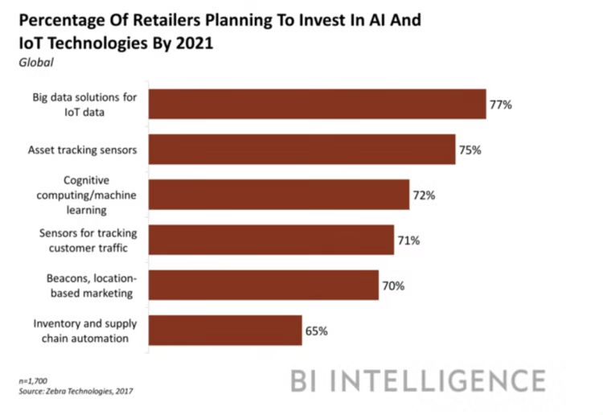

Alexa, Google Home devices and Chabot’s Artificial Intelligence has already been a part of our lives. Artificial Intelligence in ecommerce has improved the entire experience of online buying and selling and adding a personal touch to the Customer Experience.

**E-Commerce Facilitators:**

(1.) Internet

(2.) Social Media

(3.) Analytics

(4.) Payment Gateway

**Applications of Artificial Intelligence in E-Commerce**

**(1.) Personalization of Online Purchases**

Artificial Intelligence in E-Commerce offers personalized and interactive buying experiences. With AI-enabled systems, companies can view their customers, their preferences etc. AI can find customer behavior through personalization, by analyzing their clicks.

**(2.) Visual Search**

Artificial Intelligence enabled visual search for identical or similar visual search. A Product picture is worth a thousand search, visual search can solve the problem of inaccurate search queries.

**(3.) E-Commerce Catalog Management**

It is important for online retailers to have good catalog management for a better user experience. An online E-Commerce catalog provides product names, descriptions, prices and other related information. Within those thousands of product categories, small details like color, texture, pattern, style, sleeve, length need to be accurately mentioned in the catalog to help customers get the right product information. The use of AI in E-Commerce catalogs can now help in obtaining accurate and consistent data for getting deeper catalog insights.

**Application of AI in Entertainment**

**Introduction**

The entertainment industry in a vast industry and different type of stream it blooms daily by going second an AI has its credit max entertainment companies adopt AI in the year of 2011-2020 with the help of AI the growth rate of this industry was become 8.2 % the max in year of 2017

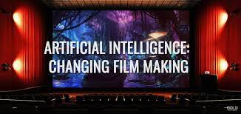

**Application**

A customer experience personalization become more complicated and tedious job for the entertainment companies uses the AI example – recommendation system

**Auto generation of thumbnails**

Showing video frames as an initial point for thumbnail the AI goes through thousands of frames to see which is perfect and have better clear view and max content and choose single frame as a thumbnail

**Film editing**

Using manual information adding effects and convert inti 3d it is basically done manually now days the AI in generating 3D effects is yet not completely developed it is can also be seen as VR virtual reality

**Streaming quality**

By using the historical data it can act your streaming quality but it can change according to the bandwidth can be access by the device

**Auto generation of advertising**

The AI will auto generate the banner and posts by using the data it can also decide the platform to shows advertisement

**Search optimization**

There is the vast on the internet or on the platform of our entertainment source the AI help us to final exactly what we needed (7) at last

**Caption generation**

Now days entertainment had become international of different religion and language that’s why today‘s AI convert the speech into text in language we can understand.



**Famous AI**

**Netflix –**has become the best source of entertainment in in the upcoming world it contain the best the bet feature are operated by the AI` such as recommendation system, auto generation of thumbnail, streaming quality, search optimization, caption generation

**Alexa amazon music**

Similarly it work with AI operation with voice search and recommendation with past work

-Recommendation

-Search optimization

-Caption generation

**Alibaba Laban**

The AI used for development posts and banner it can generate more than 8000 in a second

**Cons**

AI can’t answer question that have broad answer

AI can’t analyze data from consumer

AI can’t write address

**Pros**

AI can target people for product

It can easier to remove the manuals work

**Application of AI in the banking and finance**

**Introduction: -** The impact of AI in banking industry is more than the other industries. For organizations working in the banking industry and for that, their adoption of AI in the industry.

**Application of AI**

**1 AML Pattern detection: -** AML stands for the anti-money laundering. It is a procedure, rules and regulations or we can say law that stop generating income through illegal means. In most cases money launders tries to hide money is legitimate.

**2 Fraud detection: -** it is the field which had the major development in AI. It will become more accurate and superior results. Starting from early example of successful implementation of data analysis techniques in the banking industries in FICO Falum assessment system based on a neural network shell.

**3 CHAT bots: -** chat bots are AI based on automated chat systems which simulate human chats without any human intervention. The identity context and emotion of human and give responses appropriately. They are best in understanding human emotions.

Chat bots are used in banking industry to revolutionize the customer relationship on personal level.

**4 Recommendation: -** recommendation system are key contributes and work in every sector. In banking is based on the past data about various offers such as credit card plans, investment strategies, funds etc.

**5 Algorithm trading: -** Plenty of hedge funds across the globe are using high end systems to deploy AI models which learn by taking input from financial market and make industries decision fly.

**Famous AI**

ZAML made by Zest Finances for AML

Kai is a Chabot created by kasisto

Shape security is a fraud detector used by top banks of us

Dark trase the best AI against cyber crime

**Pros**

1 Better customer support

2 Enhanced banking services

3 Advanced data analysis

**Cons**

1 highly expensive

2 Bad Calls

3 Unemployment

**Application of AI in ROBOTICS**

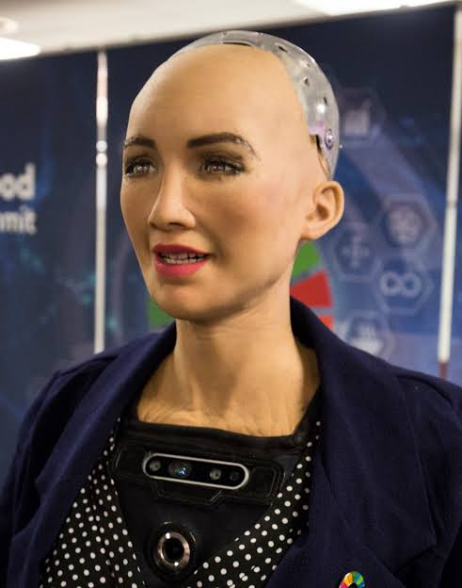Artificial intelligence (AI) and robotics are a powerful combination for automating tasks inside and outside of the factory setting. In recent years, AI has become an increasingly common presence in robotic solutions, introducing flexibility and learning capabilities in previously rigid applications.

While AI is still in its nascent stages, it’s been a transformative technology for some applications in the manufacturing sector, although there are many that have yet to feel the impact.

**Robotic Applications that Use Artificial Intelligence:**

**1. Assembly**

AI is a highly useful tool in robotic assembly applications. When combined with advanced vision systems, AI can help with real-time course correction, which is particularly useful in complex manufacturing sectors like aerospace. AI can also be used to help a robot learn on its own which paths are best for certain processes while it’s in operation.

**2. Packaging**

Robotic packaging uses forms of AI frequently for quicker, lower cost and more accurate packaging. AI helps save certain motions a robotic system makes, while constantly refining them, which makes installing and moving robotic systems easy enough for anybody to do.

**3. Customer Service**

Robots are now being used in a customer service capacity in retail stores and hotels around the world. Most of these robots leverage AI natural language processing abilities to interact with customers in a more human way. Often, the more these systems can interact with humans, the more they learn.

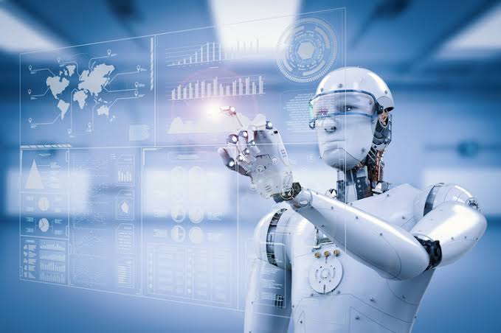**4. Open Source Robotics**

A handful of robotic systems are now being sold as open source systems with AI capability. This way, users can teach their robots to do custom tasks based on their specific application, such as small-scale agriculture. The convergence of open source robotics and AI could be a huge trend in the future of AI robots.

When working together, robots are smarter, more accurate and more

Profitable. AI has yet to come close to reaching its full potential, but as it advances, so will robotics.

**Conclusions**

To summarize, the world is on the cusp of revolutionizing many sectors through artificial intelligence and data analytics. There already are significant deployments in finance, national security, health care, criminal justice, transportation, and smart cities that have altered decision-making, business models, risk mitigation, and system performance. These developments are generating substantial economic and social benefits.

Yet the manner in which AI systems unfold has major implications for society as a whole. It matters how policy issues are addressed, ethical conflicts are reconciled, legal realities are resolved, and how much transparency is required in AI and data analytic solutions.74 Human choices about software development affect the way in which decisions are made and the manner in which they are integrated into organizational routines. Exactly how these processes are executed need to be better understood because they will have substantial impact on the general public soon, and for the foreseeable future. AI may well be a revolution in human affairs, and become the single most influential human innovation in history.

**References**

[www.analyticsvidhya.com](http://www.analyticsvidhya.com)

[www.builtin.com/artificalIntelligence](http://www.builtin.com/artificalIntelligence)

[www.smallbuissnesbonfine.com](http://www.smallbuissnesbonfine.com)

usmsystems.com

//albertchristopherr.medium.com

/amp/s/nickhtang.com

//becominghuman.ai/introduction-to-artificial-intelligence

www.javatpoint.com/application-of-ai

web.archive.org/web/20171213010136/https://www.buzzle.com/articles/applications-of-artificial-intelligence.html

//learn.g2.com/industries-using-ai

//analyticsindiamag.com/what-are-the-scope-and-challenges-of-using-ai-in-military-operations/

[www.britannica.com/technology/robot-technology](http://www.britannica.com/technology/robot-technology)

https://searchenterpriseai.techtarget.com/tip/4-main-types-of-AI-explained

[www.valluriorg.com/blog/artificial-intelligence-and-its-applications/](http://www.valluriorg.com/blog/artificial-intelligence-and-its-applications/)

www.leewayhertz.com/ai-applications-across-major-industries/

apps.dtic.mil/sti/citations

www.rand.org/pubs/research_reports/RR3139-1.html

//ieeexplore.ieee.org/abstract/document/

new.siemens.com/global/en/company/stories/industry/ai-in-industries.html

www.granta-automation.co.uk/news/advantages-and-disadvantages-of-robotic-automation/

www.marketsandmarkets.com/Market-Reports/artificial-intelligence-military-market-41793495.html

https://en.m.wikipedia.org/wiki/Applications_of_artificial_intelligence

www.simplilearn.com/tutorials/artificial-intelligence-tutorial/artificial-intelligence-applications

//spd.group/machine-learning/machine-learning-and-ai-in-food-industry/

//foodindustryexecutive.com/2018/04/6-examples-of-artificial-intelligence-in-the-food-industry/

//codeburst.io/top-5-advantages-of-ai-in-travel-industry-8325d186b6c6

www.analyticsinsight.net/ai-and-machine-learnings-impacts-on-the-food-and-beverage-industry/

www.newindianexpress.com/lifestyle/food/2020/sep/13/artificial-intelligence-and-the-future-of-food-industry-2195156.html

heartbeat.fritz.ai/4-applications-of-artificial-intelligence-ai-in-the-food-industry

foodindustryexecutive.com/2018/04/6-examples-of-artificial-intelligence-in-the-food-industry/amp/

www.mygreatlearning.com/blog/what-is-artificial-intelligence/

emerj.com/ai-sector-overviews/artificial-intelligence-industry-an-overview-by-segment/

www.productionmachining.com/articles/introduction-to-industrial-artificial-intelligence

en.m.wikipedia.org/wiki/Artificial_intelligence_in_industry